TEST PROCESS

**Version1.0**

**Revision**

|  |  |  |  |
| --- | --- | --- | --- |
| **Version** | **Date** | **Author** | **Content** |
| 1.0 | 25/05/2016 | Quyen Nguyen Thi Thuy | Create document |
| 1.1 | 26/05/2016 | Quyen Nguyen Thi Thuy | Update information |
| 1.2 | 02/06/2016 | Quyen Nguyen Thi Thuy | Update information |
| 1.3 | 09/06/2016 | Quyen Nguyen Thi Thuy | Update information |
|  |  |  |  |

**Team Name**

1. **Tan Nguyen Duy**
2. **Son Hoang Thien**
3. **Quan Ngo Minh**
4. **Qui Ngo Long**
5. **Quyen Nguyen Thi Thuy**
6. **Hiep Le**

Table of Contents

**1.** **Introduction** 4

**1.1.** **Purpose of Test Process** 4

**1.2.** **Scope of Test Process** 4

**1.3.** **Indented Audiences** 4

**2.** **Test Process** 4

**2.1.** **Process** 4

**2.2.** **Activities** 5

**2.3.** **Roles and Responsibilities** 7

**List of Table**

Table 1. Indented Aduiences 4

Table 2. Activities 7

Table 3. Roles and Responsibilities 7

**List of Figure**

Figure 1. Detail Process 5

1. **Introduction**
   1. **Purpose of Test Process**

This document describing the approach test activities. It identifies who will do each task, degree of tester independence, the test environments, the test design techniques.

* 1. **Scope of Test Process**

This document details the testing that will be performed by the project team for the project. It defines the overall testing requirements and provides an integrated view of the project test activities. Its purpose is to document how testing will be performed.

* 1. **Indented Audiences**

|  |  |  |
| --- | --- | --- |
| No. | Readers | Reason for reading |
| 1 | PM | Test plan, personnel involved, related documents |
| 2 | Test Leader | Guideline and approach to implement testing phase |
| 3 | Tester | Understand and implement test planed |
| 4 | Developer | Fix bug or issues are reported |

Table 1. Indented Aduiences

1. **Test Process**
   1. **Process**

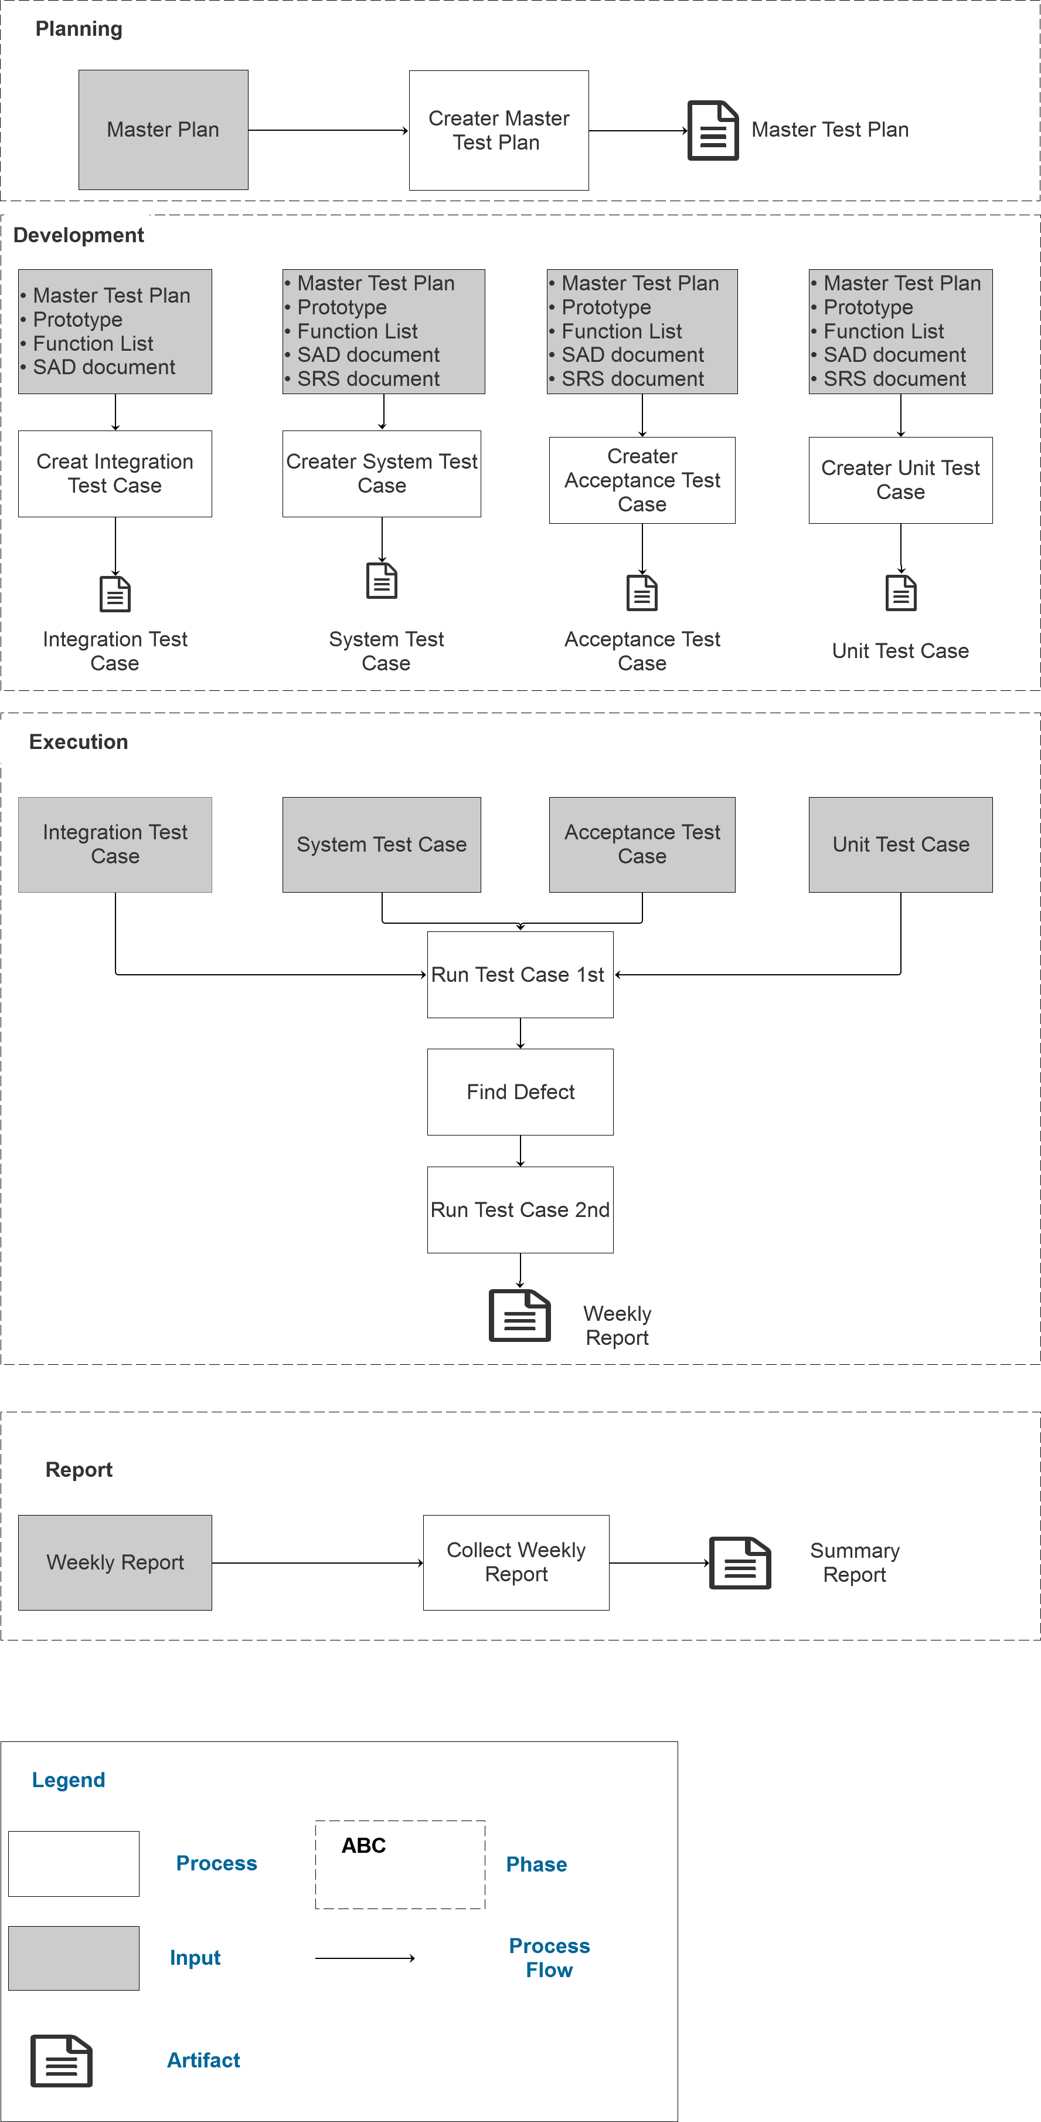

Figure 1. Detail Process

* 1. **Activities**

|  |  |  |  |  |
| --- | --- | --- | --- | --- |
| Phase | Description | Input | Output | Role |
| Planning | Test Leader will build the initial plan of testing   * Defining the scope of testing * Identify the risks and the element of surprise * Identification of active |  | Test Plan Document | Test Lead |
| Development | Tester would design of test cases from requirements relating   * Design of test cases from the functional requirements and non-functional requirements of software * The test case should cover all aspects of testing for each software requirement * The test case should cover all requirements in the test strategy   Build test scripts | * Master Test Plan * Prototypes * Function List * SRS document * SAD document | * Acceptance Test Case * System Test Case * Integration Test Case * Unit Test Case | Tester |
| Execution | Testers and Test Leader will be implement testing   * Execution of tests on each test case * Perform special tests (ad-hoc) * Perform testing scenarios which are not defined in the test case * Testing the error has been corrected   Tester will generate reports about the error during error checking and monitoring them until they have been processed | * Acceptance Test Case * System Test Case * Integration Test Case * Unit Test Case | * Weekly Report | Tester |
| Test Report | Collect Weekly Report | * Weekly Report | * Summary Report | Test  Lead |

Table 2. Activities

* 1. **Roles and Responsibilities**

|  |  |  |
| --- | --- | --- |
| **No.** | **Role** | **Responsibilities** |
| 1. | Test Leader | * Provide technical direction * Design Test Plan * Prepare summary Report * Create Test Plan |
| 2. | Tester | * Test project document * Developer test case * Run Test Case * Tracking defect |
| 3. | Developer | * Attend in meeting as defect report * Write unit test, perform unit test |
| 4. | Project Manager | * Review Test plan * Review Test schedule * Attend test report meeting |

Table 3. Roles and Responsibilities